13.15: The equation describing the motion is 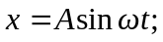this is best found from either inspection or from Eq. (13.14) (Eq. (13.18) involves an infinite argument of the arctangent). Even so, is determined only up to the sign, but that does not affect the result of this exercise. The distance from the equilibrium position is

